**Better to Light a Candle than to….**

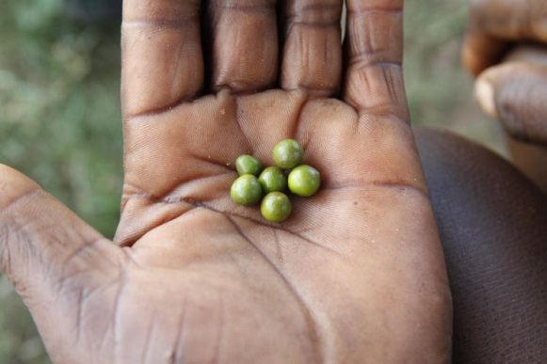Bishops' Appeal is the Church of Ireland World Aid and Development Programme.  We exist to fund projects in poor communities around the world with particular support for developments in health, education, rural development and disaster relief response.  We focus on programmes that are community led and sustainable.  We work through mission agencies who have built strong relationships within the communities and who have track records of listening and responding to identified needs.  Bishops' Appeal is also committed raising awareness about injustice and inequality.  As part of the 5 marks of mission we are challenged to expose and to transform the systems and structures that keep the majority of the world poor for the sake of keeping the minority comfortable or in gross excess.

When you donate to Bishops’ Appeal the money is used to transform lives. In March, €43,827 and £26,400 was distributed to combat extreme poverty among the world’s most vulnerable people. Eight projects were funded across seven countries.

Now, two Fields of Life projects are bringing the right to water to communities in Uganda. One project is bringing three boreholes to three villages; the other is helping a school of 900 students harvest rainwater. With access to water at school, girls are able to attend during their menstrual cycle.

Feed the Minds is providing agricultural support and functional literacy to communities in Northern Ghana. With 43% of homes in the region experiencing food shortages for two to five months of the year, this project is targeting 400 farmers to increase their food production and to generate income from excess crops.

Team Hope is educating communities in Tanzania in conservation farming methods. With 80% of the population dependent on the land, there is poor soil, land scarcity and an increase in deforestation. These methods increase harvests in limited spaces. Team Hope is running this programme through the local church.

Christian Aid is helping people in Angola respond to extreme drought coupled with abnormal rainfalls which drastically affect food production. Working alongside five communities, they will train in sustainable agricultural practices as well as setting up micro-credit schemes and providing business training. They are working through the local churches.

Tearfund Ireland is mobilising churches in seven districts in Zimbabwe to respond to the needs of 2,500 orphans and vulnerable children. Alongside training, they are providing support to families and widows who take in orphans. By providing livestock they increase the ability of families to provide for those in their care. This

The Mission to End Leprosy is working with Rohingya Refugees in Bangladesh and is treating those with leprosy and with other skin diseases. Over the next year they will treat 30,000 cases of skin diseases and provide medication and support to 50 people identified with leprosy.

CMS Ireland is supporting the Diocese of Egypt Youth Refugee Programme. 240 young refugees will receive training in business skills and self-sufficiency so they can provide for those in their care. Others will receive humanitarian assistance combined with outreach programmes such as English classes.

For these programmes and for the Church of Ireland support which allows them to happen, we say thank you for your support and Glory be to God.